Azure Backup

1. Site recovery solutions is completely replicating the resources/ back up the resources. Back up and recovery services both are integrated with the same that is Recovery services Vault

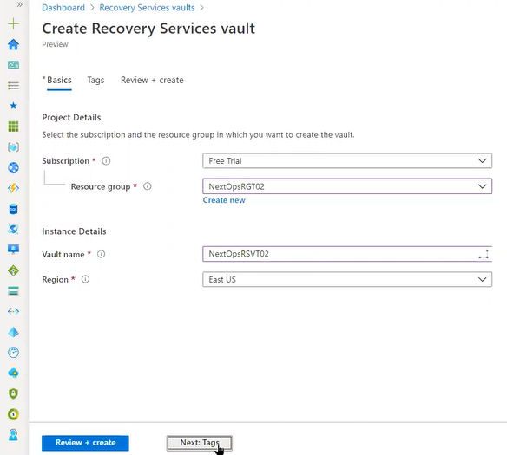

Create Default options and next

1. Back up/site recovery cloud is the best option because it lifts off site work by means of tape
2. We can replicate to multiple regions and it is high availability. how we enabled the monitoring likewise we need enable Backup so that an agent is installed called mabs agent
3. For taking the back up we need Azure backup server/ Data protection manager in place to be installed or that is a lengthy process there will be Azure back up server is on premises centralized host it will take all on premises machines backup locally

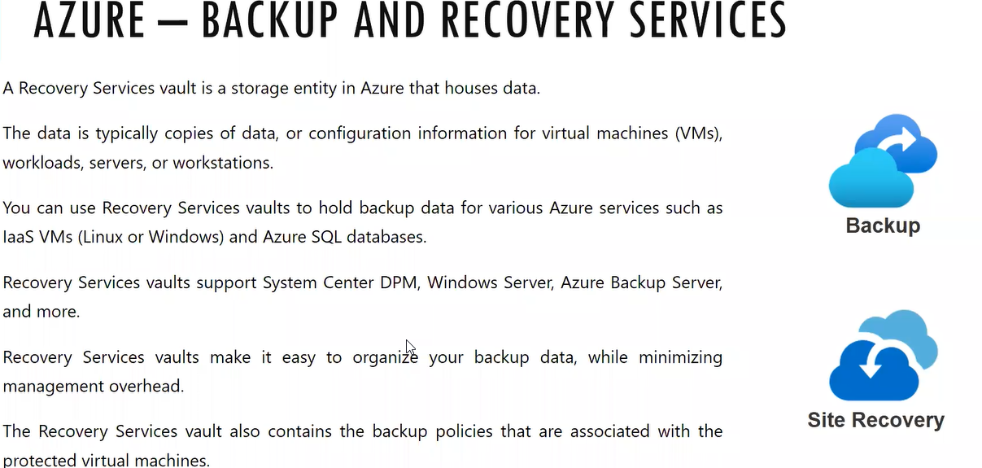

1. ASR: Azure site recovery
2. Back up and recovery both are used to protect the disasters. Back up is running on regular intervals based on the schedules generated for sql schedule it is created to take back up four times every day
3. Recovery time objective: how much time it will take for recover how many back ups are needed to recover and how much time it will take restore the back up  
   Recovery point objective: how much data will be loss
4. In the backup scenario there is little data loss occur
5. Site Recovery: Primary data center to secondary location complete infrastructure will be copied/replication/synchronized
6. If you delete the file in the back up we can restore it from old back up file where is in the site recovery we cannot get the delete file since it is synchronized from primary to secondary server
7. Site recovery is live replication. RTO and RPO will be low

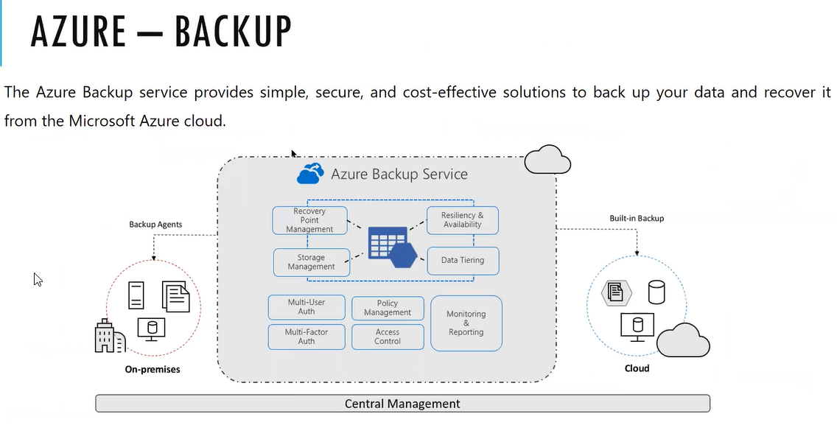

1. we need enable Backup so that an agent is installed called mabs agent
2. we can take up back up by means of extensions or agents ( it is manual and we need to connect to service vault which is applicable to azure and non azure)
3. Microsoft back up server which is centralized and will connect to all 100 machines and agent will be pushed so azure will just connect to just Microsoft back up server
4. DPM enhanced version is Azure back up service
5. If you install DPM then we need to download the correct version of SQL if that versions that does not match then we will get uses where as for the Azure Back Up services the sql is integrated

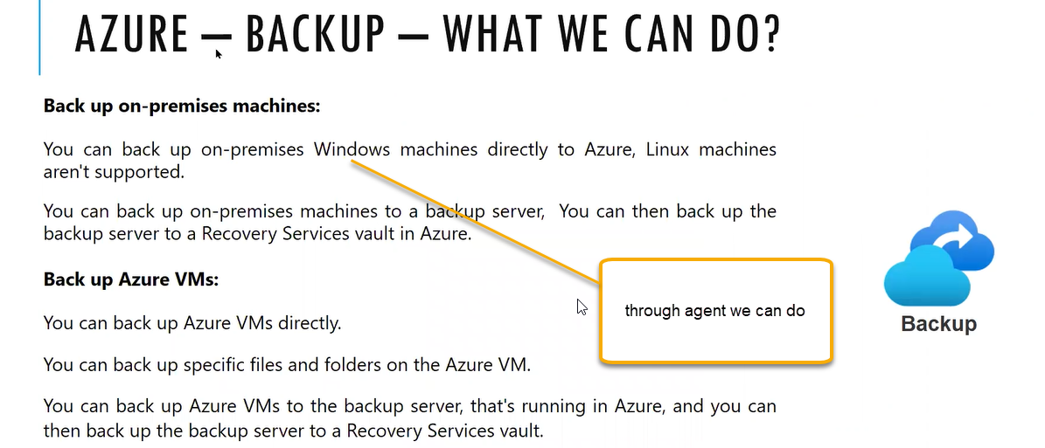

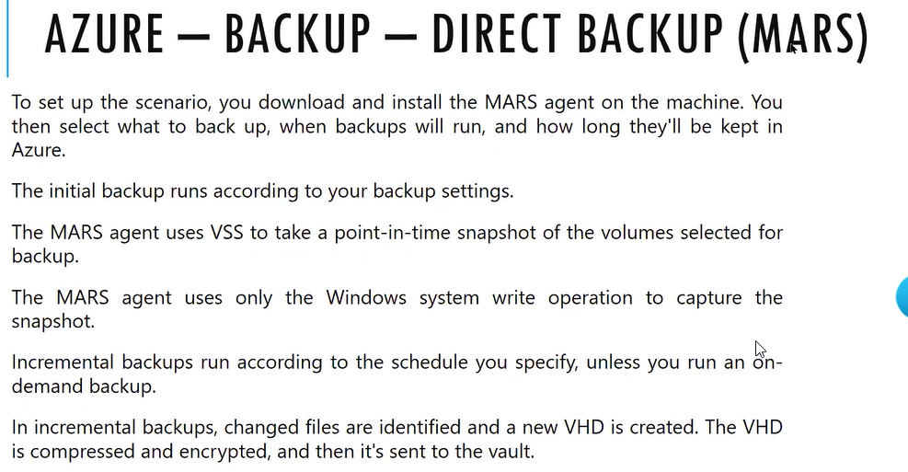

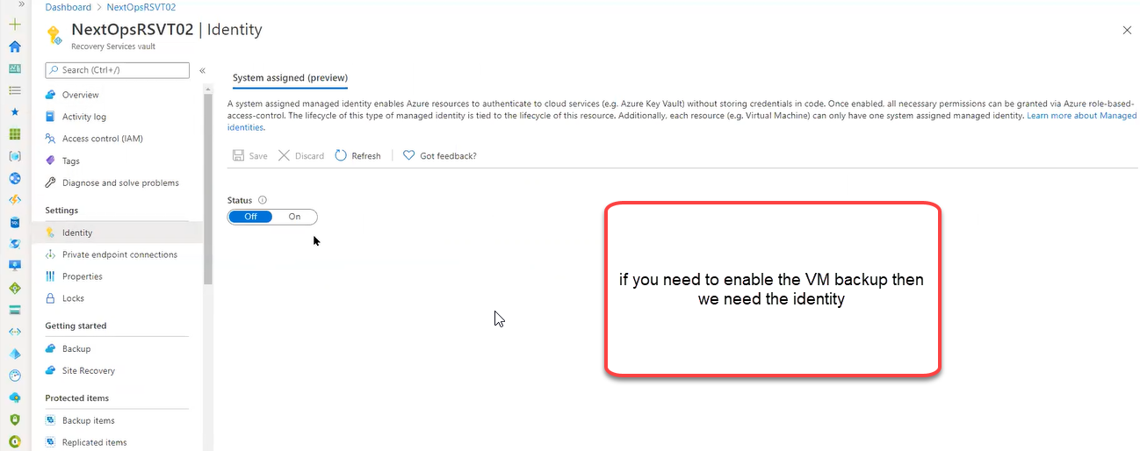

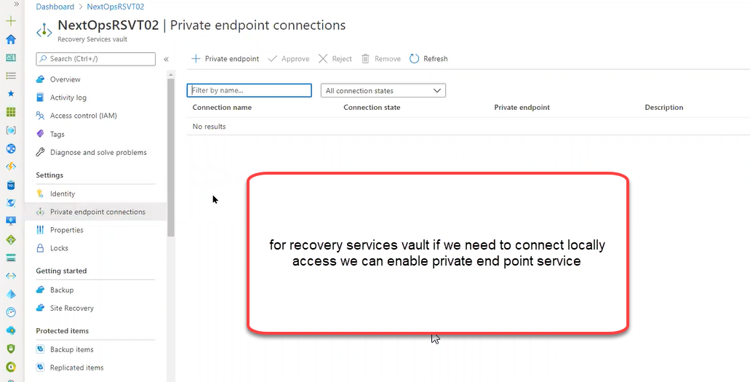

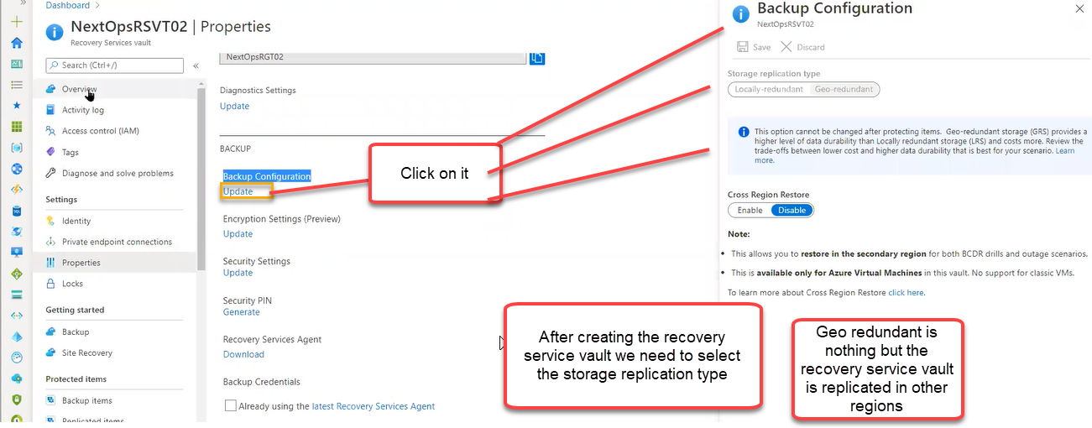

Any accidental deletion we can do it from security settings

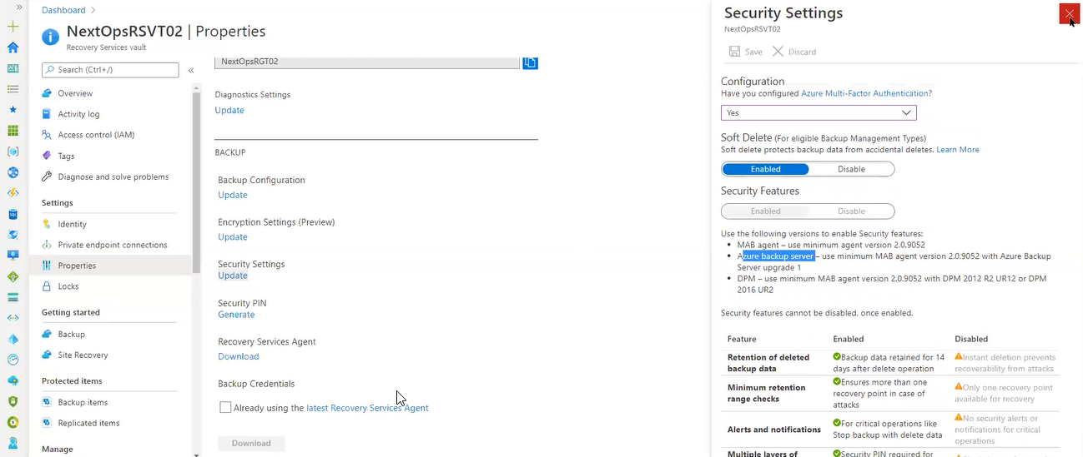

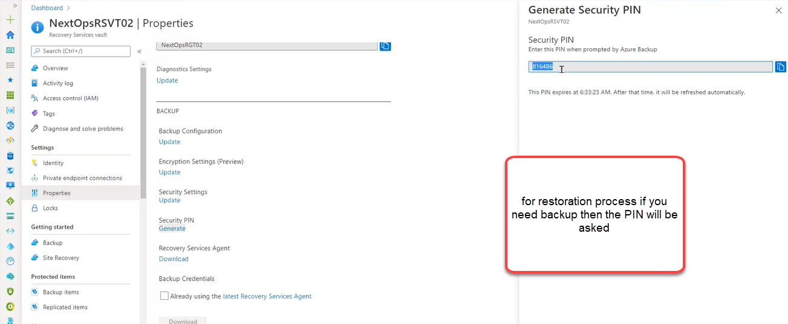

The PIN will be refreshed automatically for every 5 minutes

Recovery service agent: From this only we will download the agent

If you want to connect to recovery services vault, then we need to download the file this are called file credentials.

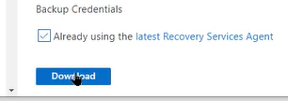

This are called vault credentials



While installing the agent this file will help us to connect the recovery services vault

Back UP

There are different scenarios

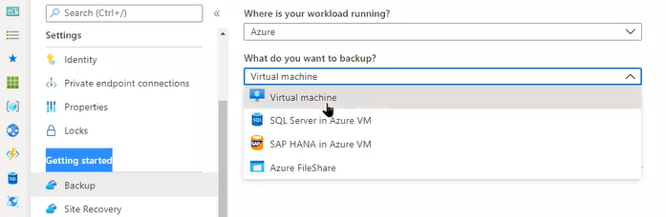

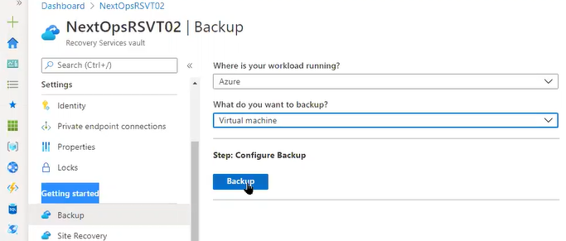

Snapshot: we can instantly restore it which is faster than back up. The instant restore is default however we need to mention the days

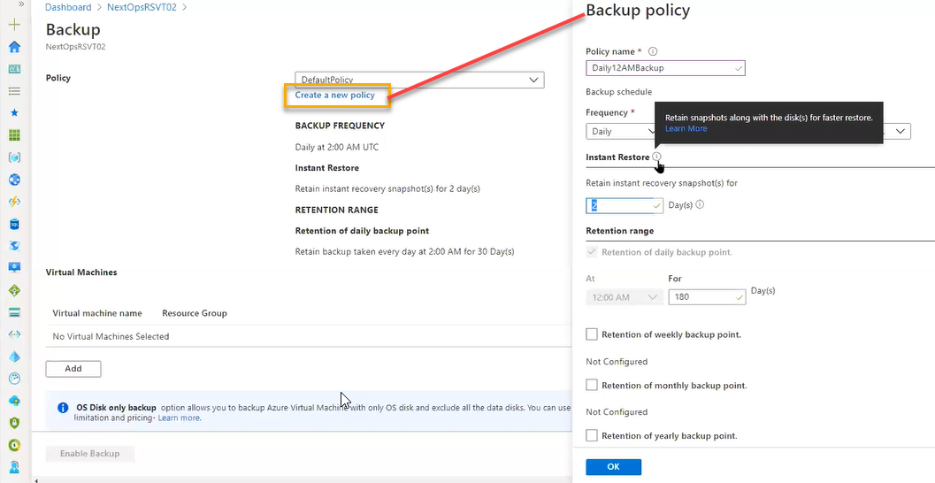

180 days: Continuously the back up will be restored for 180 days

Daily: Differential back up

Weekly: incremental back up

Monthly: Full back up

Daily differential will be taken (Monday to sat) and on sat incremental back up. Month end will be full backup

Click on Add virtual machines so that back up extension will be enabled NOT the agent

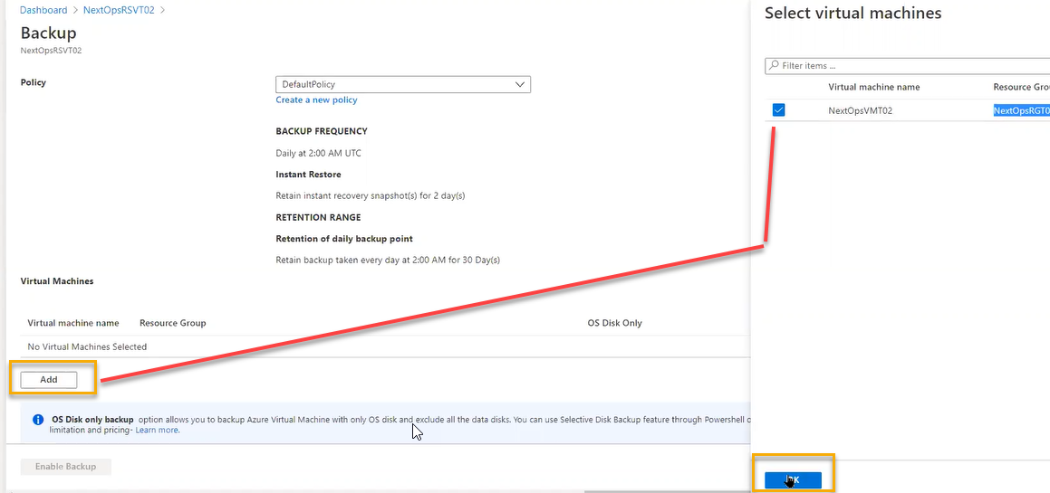

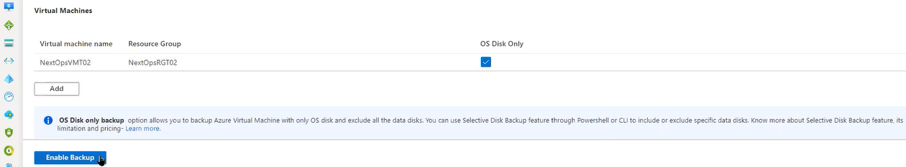

This process is applicable to Azure VMS

This extension scenario is applicable to linux also however agent based not supported

1. Initial back up will be taken and we can see same in the Backup items

Azure stack is similar to on premises

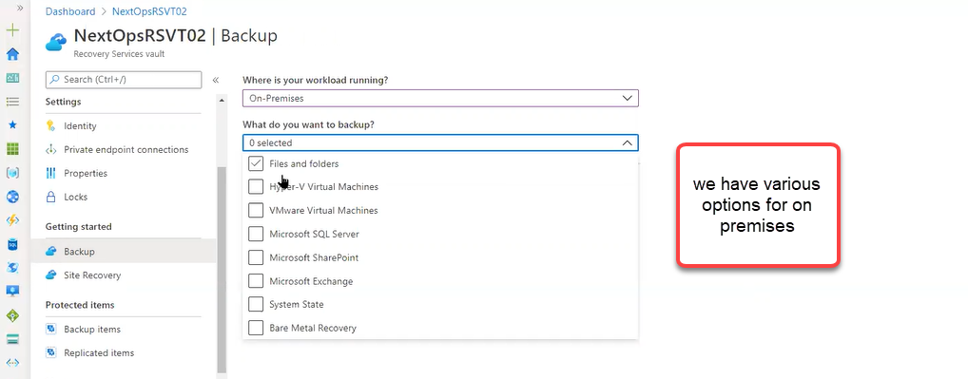

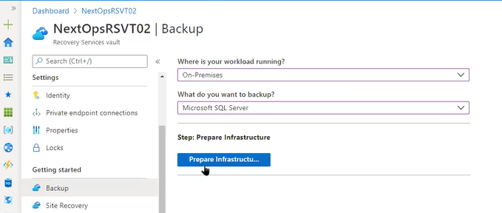

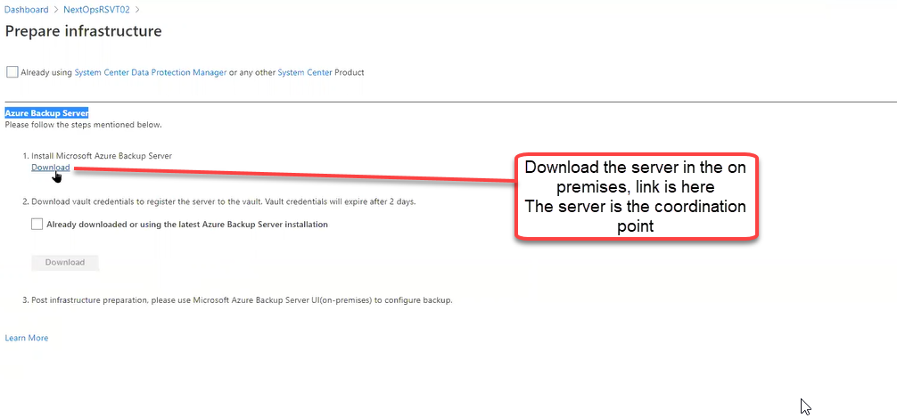

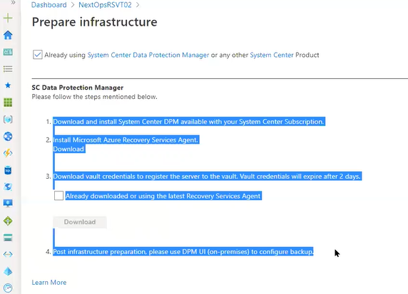

The process is different if we select the DPM

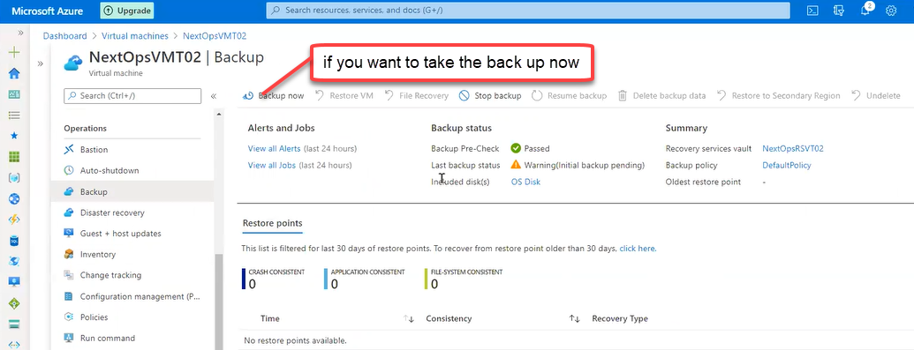

We can take the back up from the selected dates

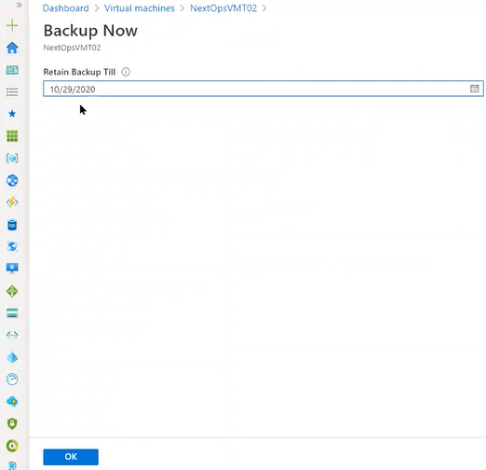

So initial back up will be triggered

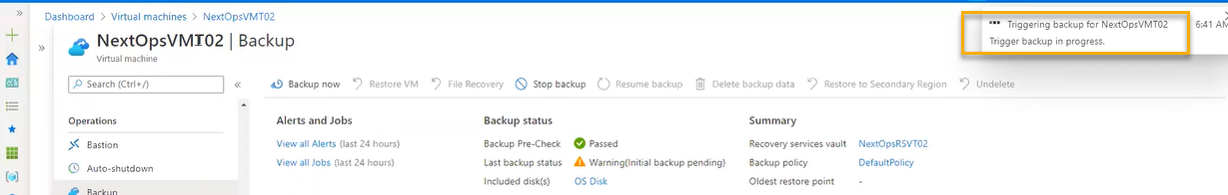

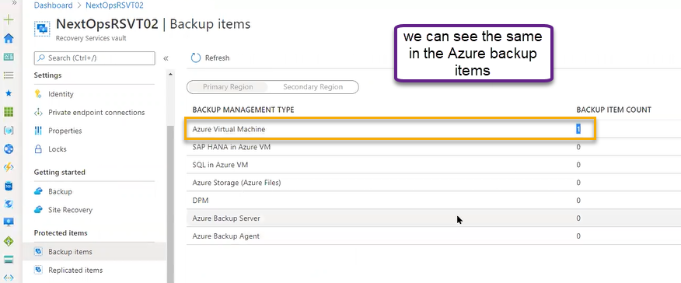

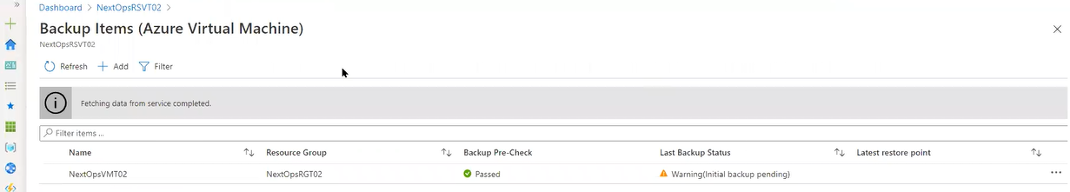

Click on the VM then the below page will opens

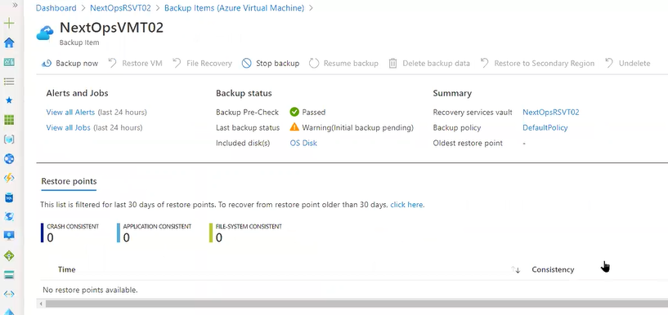

Backups jobs will be failed with respect to schedule. If you reinitiate it the fix will be done for maximum scenarios

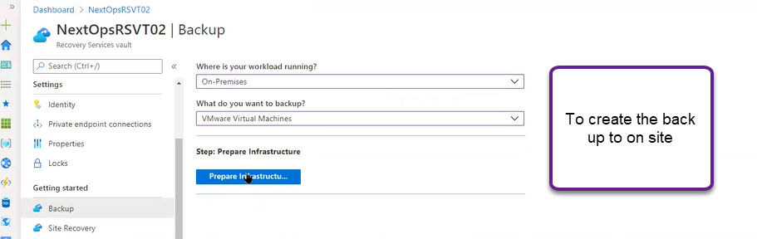

With out Active directory service we cannot manage on premises server.

AD is installed

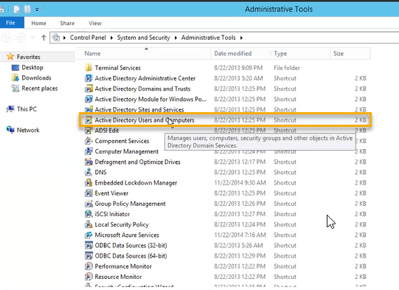

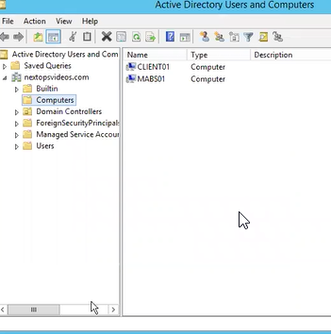

AD is installed in one device and another device we installed backup server ( for that we need prerequisite this is installed server has to be present in the Active directory)

AD is centralized administration point for managing the user authentic account

In that we joined the Client machine and Backup server as highlighted below

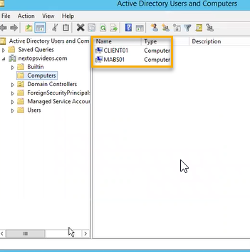

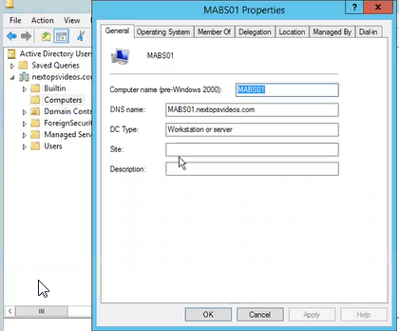

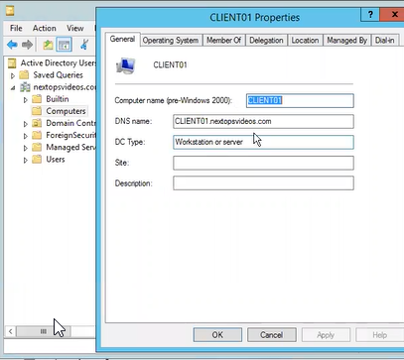

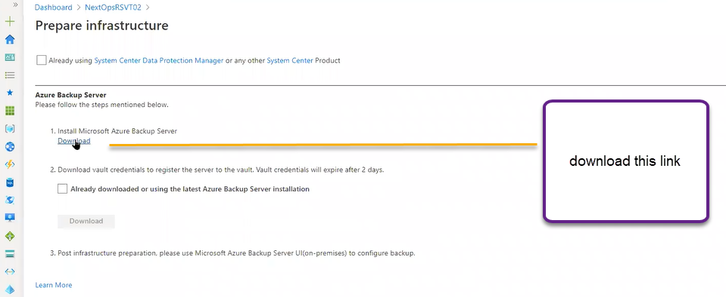

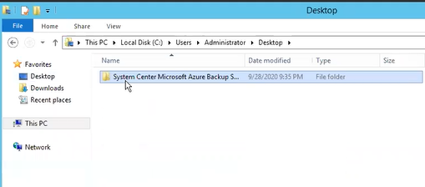

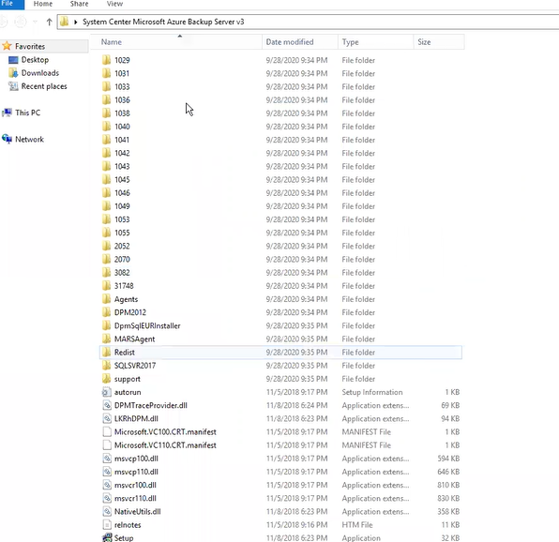

This is one GB server

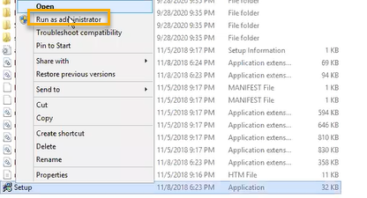

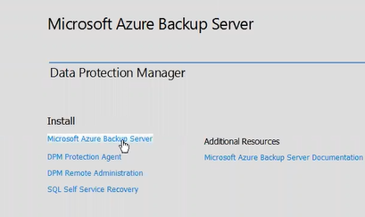

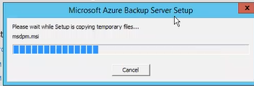

It will check the compatibility

We need .netframework 4.6,

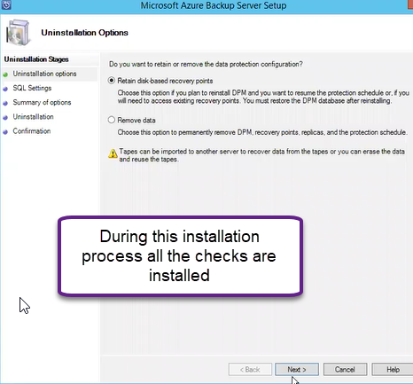

After that we will get two shortcuts

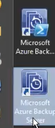

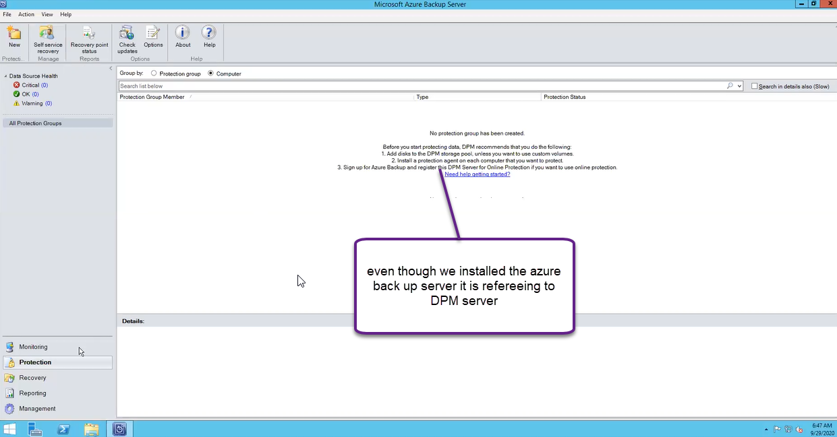

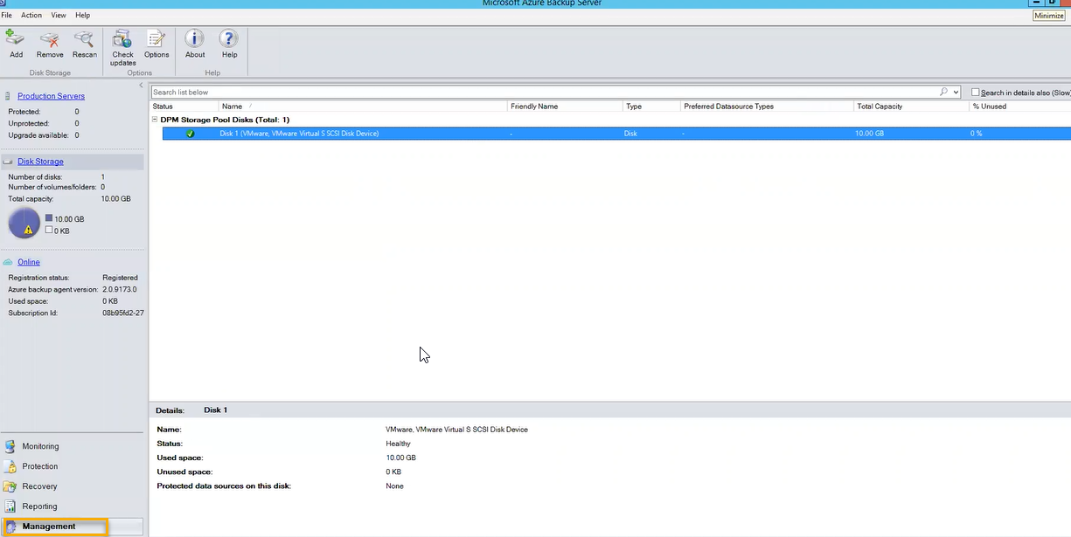

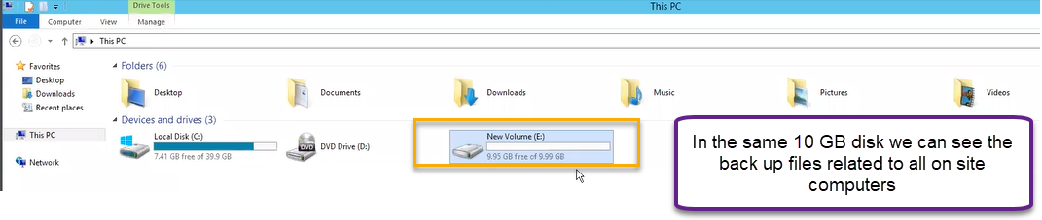

This particular we need to back up to Azure server  
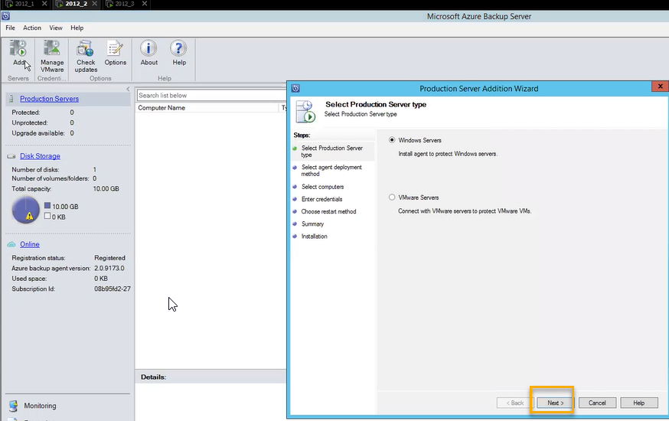

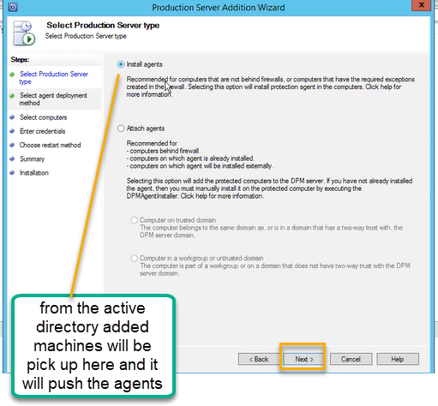

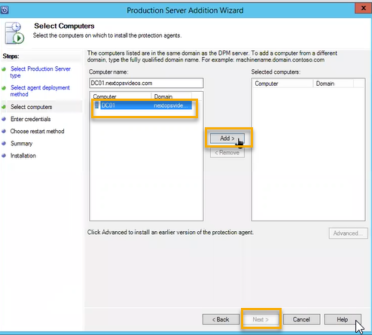

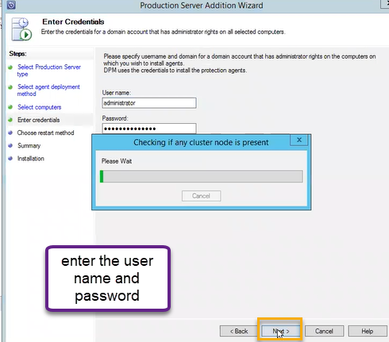

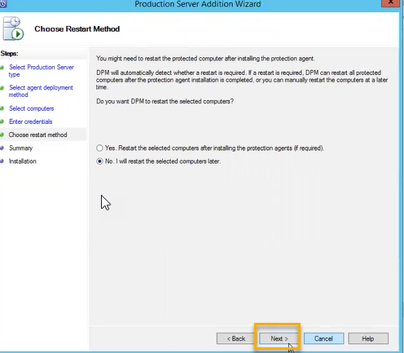

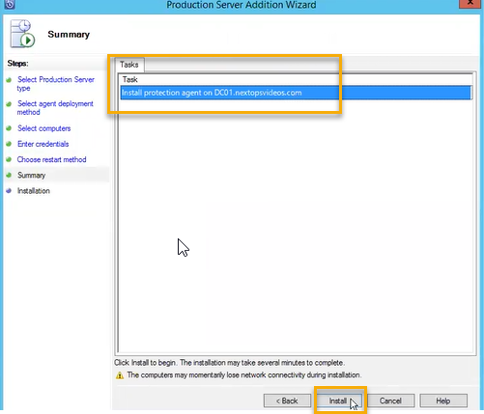

In the same way we can push to number of agents

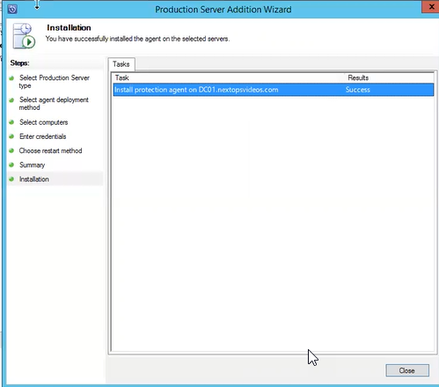

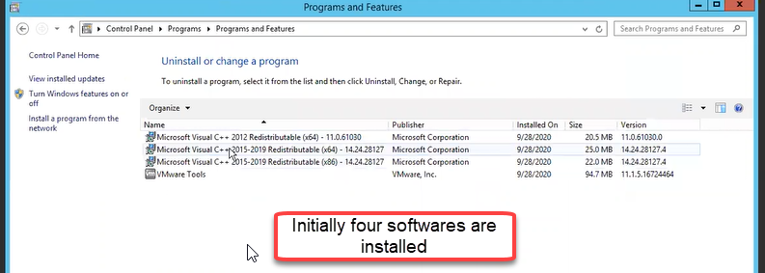

Once installed in back server we can additional server in D Machine

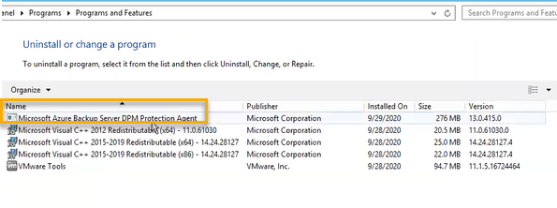

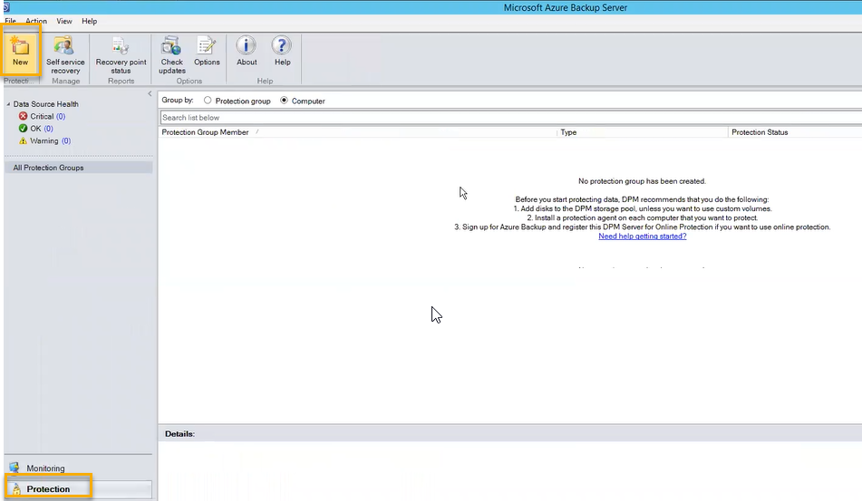

In the Monitor we will see how many jobs they are running

We can report based on pre-defined reports

In the management we will see servers have been added

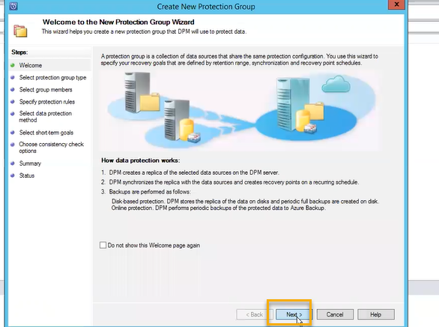

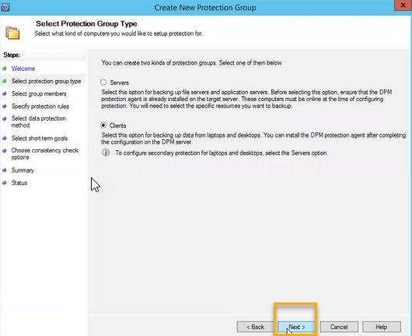

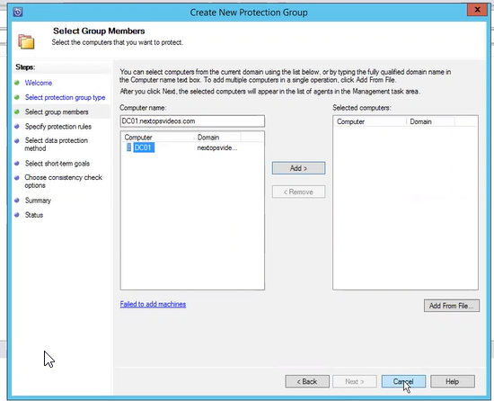

Registration process

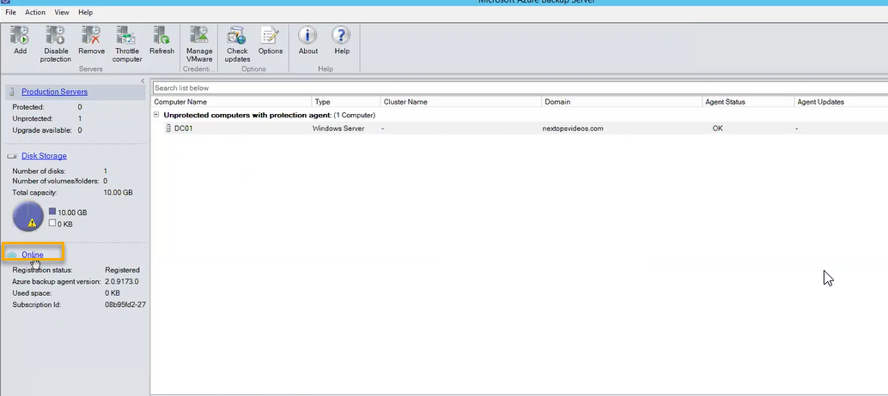

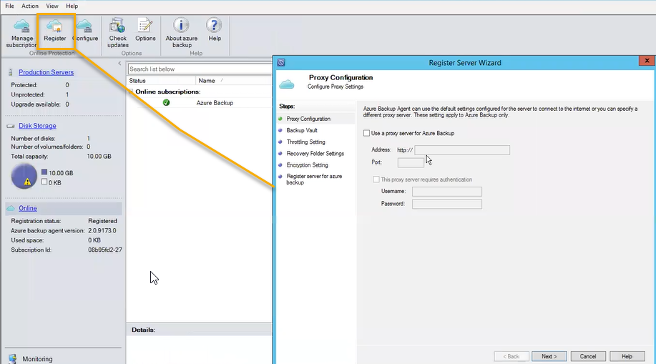

Click on Next

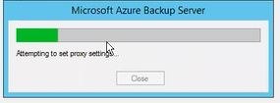

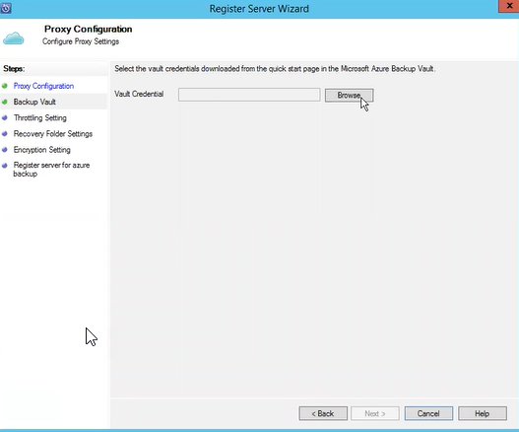

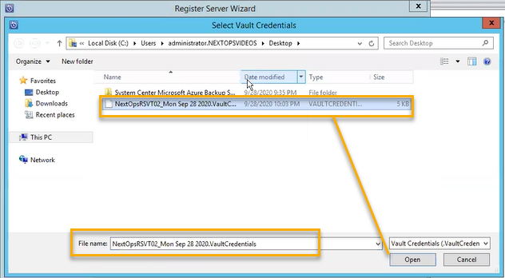

It will read it whether it is valid or not, using that credentials it will connect to azure back up vault to this backup server

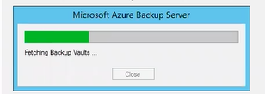

We can download the keys from the below place

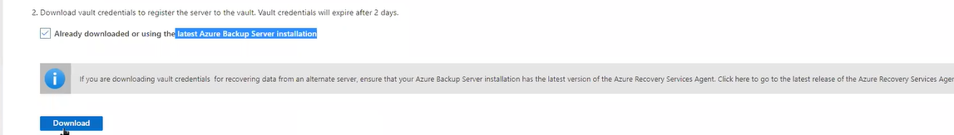

After downloading we can see the shortcut

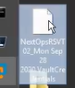

After that a connection will be established between Azure and on premises and we can see the below location

Below we can see how the connection was made from Azure to on premises

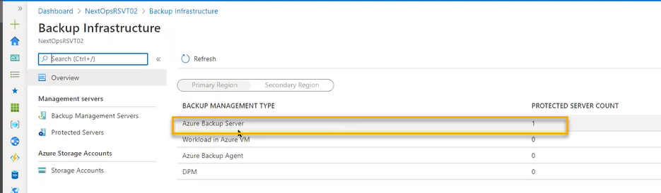

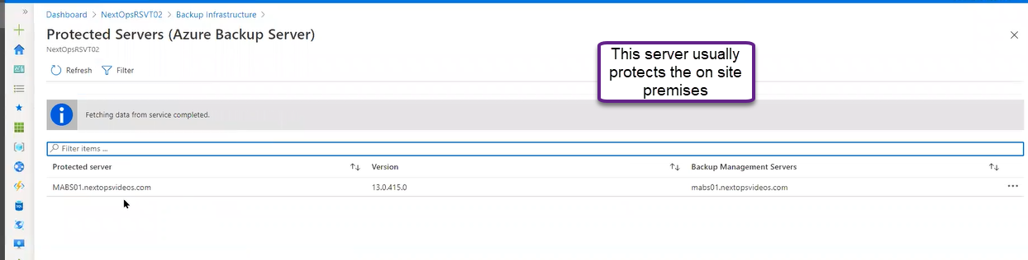

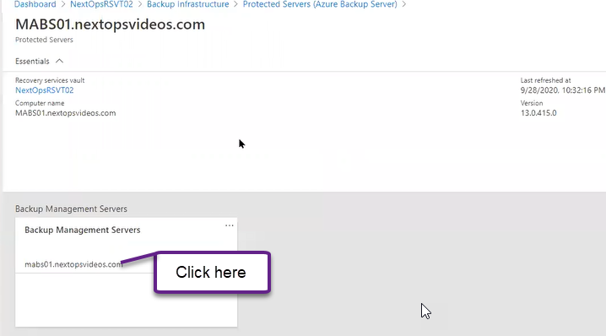

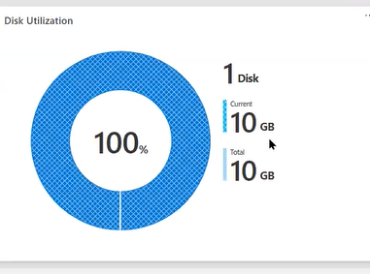

And we the same in the management section in on premises

Direct Installation

We are not contacting with back up server and it is independent machine

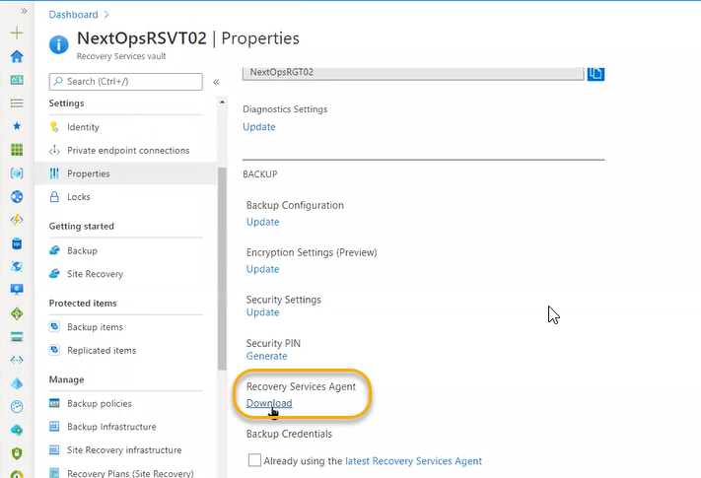



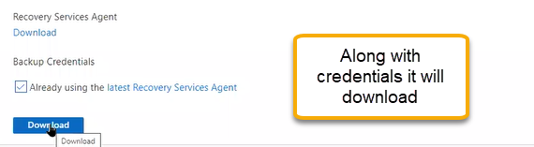

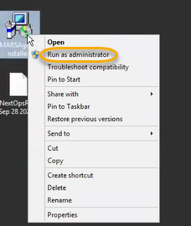

It will connect to cloud as a independent machine

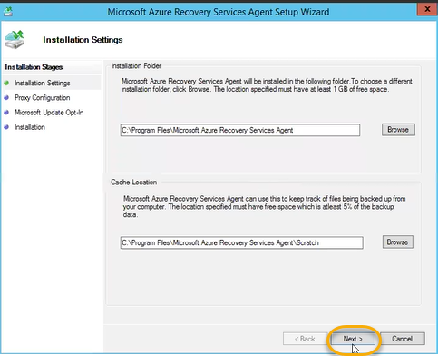

Click on again Next > do not use update > Next

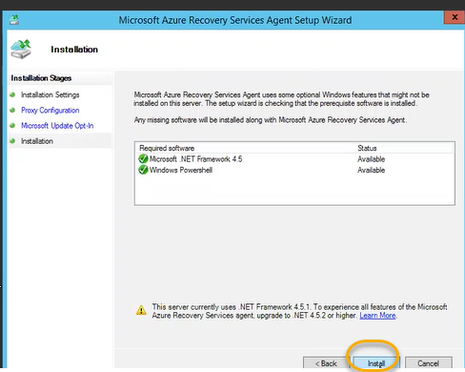

After installing we need to register it to the cloud

We need to register to recovery services vault

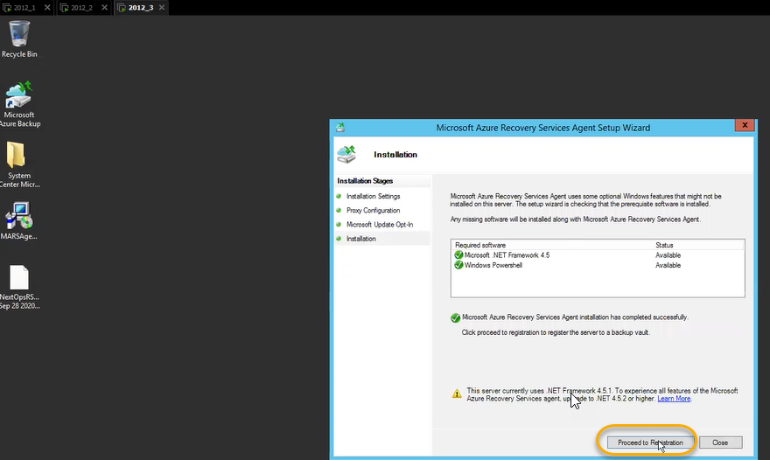

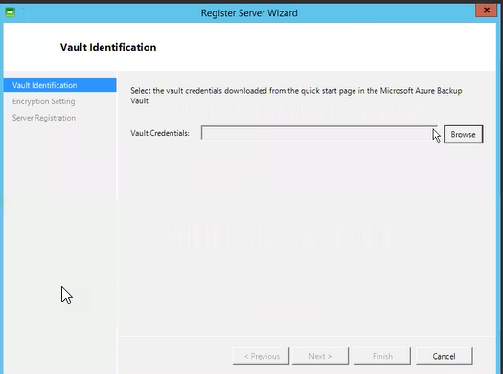

Along with the credentials

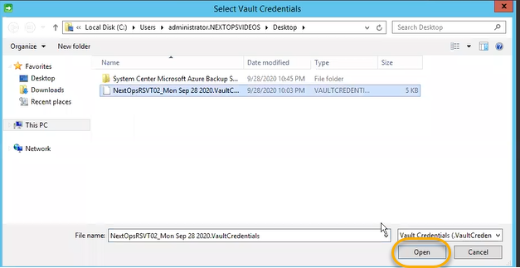

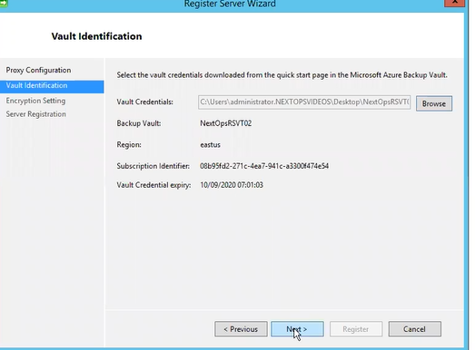

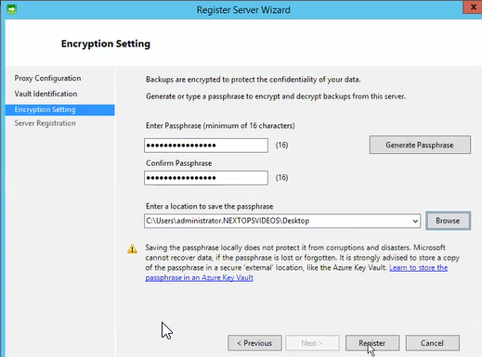

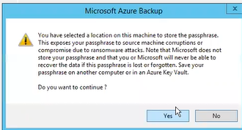

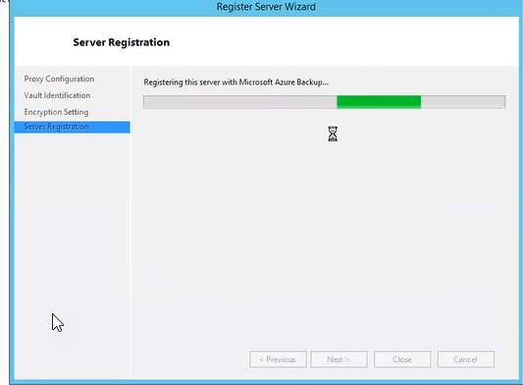

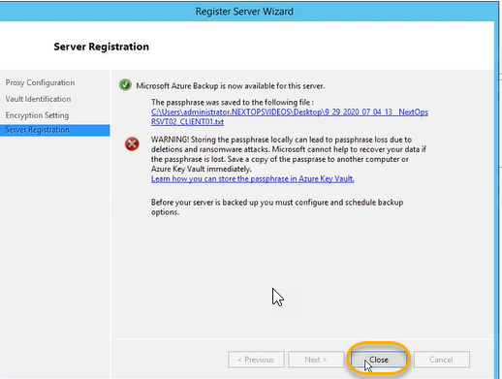

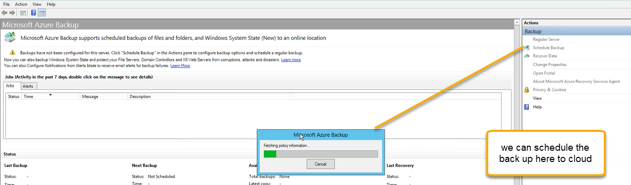

And we see the same in the below points the point 1 is increased

